

**CMPE-277: Smartphone application Development**

**Assignment 3 – BROADCAST RECEIVER**

**Submitted to:** Prof. Chandrasekar Vuppalapati

**Submitted by:** Anuradha Rajashekar

(SJSU ID: 012409956)

1. This assignment describes the functionality of a broadcast in android. There are 2 apps namely “Currency Converter App” and “Currency Conversion Exchange”. Below Screenshot is UI for first app which sends broadcast to second app.

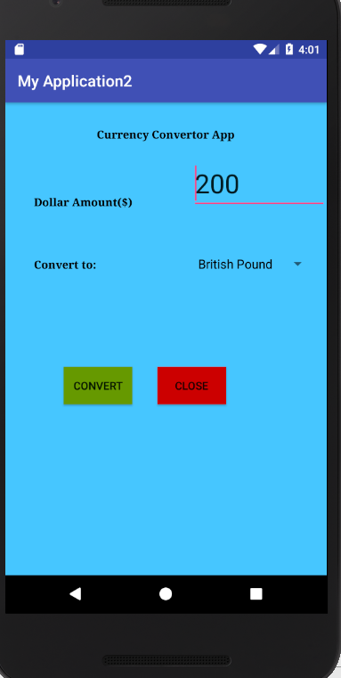

1. First App takes input “Dollar Amount” and Currency type and sends a broadcast on click of convert to Second App. Toast will be generated once broadcast is received.

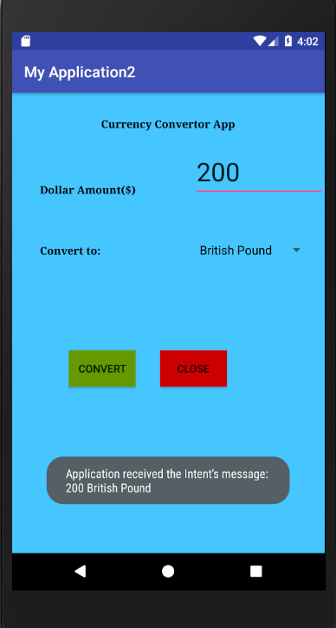

1. Below screenshot is the UI for second App. It receives Dollar Amount and Currency as broadcast from First app.

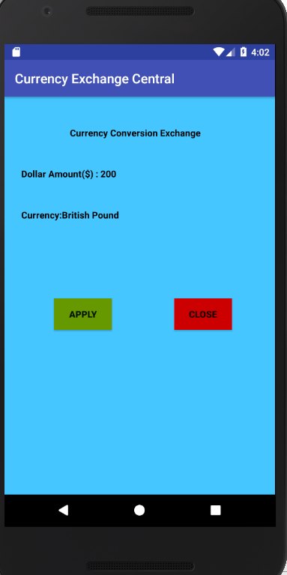

1. On click of Apply from Second app a broadcast is sent to first app with a text of converted value.

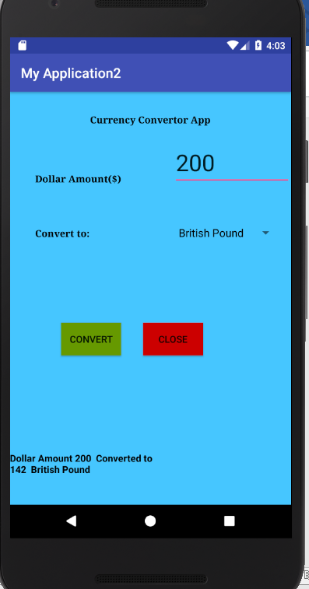

1. Below screenshot exhibits the same functionality for currency “Euro”.

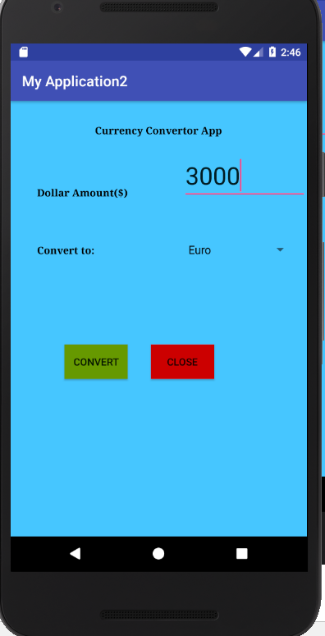

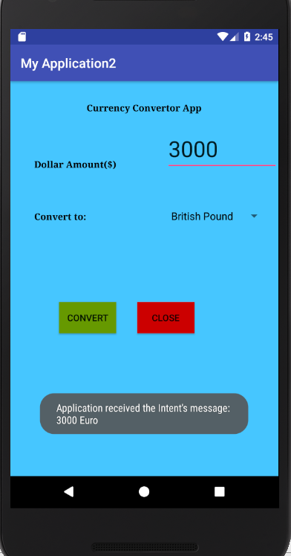

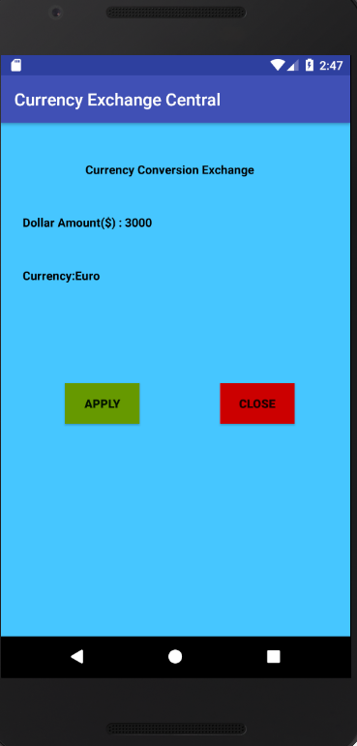

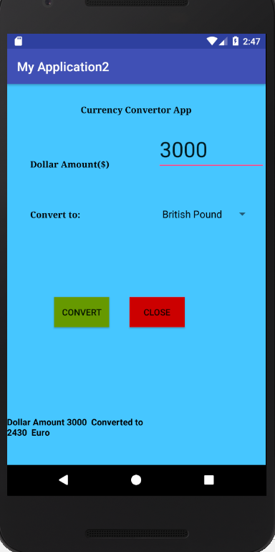

1. Below screenshot exhibits the conversion for “Indian Rupee”.

